CURATE
Product Strategy, Validation Roadmap & Google AI Studio Build Specification
Final consolidated document — October 2026
North star
Everything worth exploring. On your schedule.

Working name: Curate. This document consolidates the two supplied source documents and the decisions selected during reconciliation. Core product remains non-AI; optional AI is not on the committed roadmap.

Executive summary
Topic | Decision
Core problem | People save too much interesting content and rarely consume it.
Core loop | SAVE → ORGANIZE → PLAN → CONSUME → COMPLETE
Product | Visual planner for YouTube videos, articles, podcasts and books.
Wedge | Visual curation + time-aware consumption planning.
Primary promise | Turn the content you save into a realistic schedule you can actually follow.
AI stance | No AI in the core product. No AI roadmap commitment; revisit only if users demonstrate a problem deterministic planning cannot solve.
90-day objective | A → B → C: prove people want the product, get to 100 users, then prove first revenue.

Three biggest opportunities
- Own the space between visual curation and actual consumption planning: the product turns saved content into scheduled consumption.
- Make time-aware planning the utility layer: weekly available time, duration, drag-and-drop, and a visual calendar give the product a job beyond bookmarking.
- Build a calm, non-AI product with deterministic planning. This keeps costs predictable and makes the product feel like a focused tool rather than an AI wrapper.

Three biggest problems
- The screenshots communicate save/curate better than why a user should schedule.
- The calendar can become a beautiful planning surface without creating a completion or weekly-return loop.
- The visual concept invites feature sprawl before product-market signal; social, AI, gamification, complex tagging and large integrations must remain gated.

Reconciled decisions
Decision | Final choice
Build sequence | Combine product-validation order with the technical implementation path. Every technical stage has a product gate.
Real-link capture | Later, after the core planning behavior is validated.
Long-content sessions | Later, after core planning/retention validation.
Sharing | Both: Share My Week first, shareable collections later.
Calendar integration | Post-90-day milestone with a retention gate.
Pricing | EUR (BGN) 5/month and EUR (BGN) 39.99/year as the initial pricing hypothesis.
Payment validation | Public beta first; no rigid 30-user/3-buyer gate.
AI | No planned AI stage. Only revisit if future research demonstrates a real need; if added, it must be optional and replaceable.
Working name | Curate
Accounts | Guest/local use first; accounts and cloud persistence after initial product validation.
Activation | Start with 3–5–1; also measure whether 5 saves / 3 scheduled is a stronger predictor of retention.
Planning | Time Budget + Quick Plan are built as one combined core feature.
Sharing sequence | Share My Week first, then Share Collections.
Public sharing | Anyone with the link can view; account required to import/save.
Archive | Do not add yet; decide after larger-library testing.
Priority | One simple Priority toggle.
Quick Plan behavior | Default automatic selection plus an advanced rule selector.
Long content before Sessions | Keep as one item; no duplicate-day workaround required.
Analytics | Umami + first-party product events.
Document structure | Part I: Product Strategy; Part II: Combined Validation + Build Roadmap; Part III: Technical Build Specification; Part IV: Google AI Studio prompts.

Part I — Product strategy

1. Product audit

What Curate does
Curate lets users save YouTube videos, articles, podcasts and books into a visual infinite canvas, keep unscheduled items in an Inbox, and then schedule them across a calendar using Day, Week and Month views. The central transformation is from “interesting things I have saved” to “the things I will actually consume this week.”

Who it is for
Segment | Pain | Why Curate fits
Visual learners / knowledge collectors | Large backlog of tabs, bookmarks, Watch Later queues, podcast episodes and books. | Visual canvas makes the backlog feel curated; calendar converts it into action.
Knowledge workers, designers, creators, marketers, founders, engineers | Need structured time for learning and research but rarely have a realistic consumption plan. | Time Budget + calendar gives content a place in the week.
Cosmos / Readwise / Pinterest / Are.na fans | Want calm, image-first, aesthetic tools instead of tables and project-management dashboards. | Current visual language fits; scheduling becomes the functional wedge.

Core value proposition
Primary: Turn the content you save into a realistic schedule you can actually follow.
Secondary: Curate your interests visually, then decide when you will watch, read, listen, or learn.

Screenshot-based UX findings
Issue | Why it matters | Final direction
Collection is clearer than consumption | Home can be interpreted as a visual bookmarking app. | Make the save → schedule relationship explicit in the hero and empty state.
Calendar is powerful but under-explained | Dragging cards is clear; the reason for doing so is less explicit. | Use the 3–5–1 activation path and Time Budget.
Empty state needs purpose | Blank canvas can look unfinished. | Use “Start with 3 things you want to consume this week.”
Completion loop is not obvious | Planning alone can reduce the product to a prettier calendar. | Add Saved → Scheduled → In Progress → Completed → Skipped and Weekly Review.
Feature-sprawl risk | The canvas can support many directions. | Protect the core loop and gate major additions.

Aha moment
Recommended behavioral definition: a user saves 3–5 pieces of content, schedules at least 1, and opens the calendar to see a coherent plan. Target time-to-aha: under 3 minutes.

Secondary activation metric
Also measure whether users who save 5 items and schedule 3 are more likely to return the following week. Do not replace 3–5–1 before collecting evidence.

2. Market & competition
The relevant competitive set is not only calendar software. Curate sits at the intersection of visual bookmarking, read-it-later/reference tools, and personal planning. The opportunity is the gap between these categories.
Competitor/category | Strength | Curate differentiation | Pricing status
Cosmos | Visual-first discovery and collection. | Add time-based planning and a consumption loop. | Current price should be rechecked on the official site before external use.
Are.na | Strong visual/idea collection and networked research. | Make collected media actionable through scheduling and completion. | Current price should be rechecked.
Readwise | Capture, highlighting, review and retrieval. | Focus on visual curation + future consumption planning rather than knowledge retention. | Current price should be rechecked.
Pinterest | Exceptional visual discovery and saving. | Turn saved content into a personal learning/media schedule rather than a discovery feed. | Freemium/ad-supported; exact commercial comparison should be rechecked.
Raindrop.io / bookmark managers | Excellent capture, organization and retrieval. | Make time and consumption the primary organizing layer. | Current price should be rechecked.

Defensible wedge
Visual curation + time-aware consumption planning. Curate does not need to beat Pinterest on discovery, Readwise on notes, or a calendar on scheduling. It combines the parts they keep separate.

Category language
Recommended: visual content planner / personal consumption planner / personal learning calendar. Avoid “content calendar” as the primary category because the phrase is strongly associated with social-media publishing.

3. Feature strategy and prioritization
Feature | Purpose | Impact | Effort | Confidence | Priority
Messaging + empty state | Activation | 9 | 2 | 9 | Critical
3–5–1 activation flow | Activation | 10 | 3 | 9 | Critical
Time Budget + Quick Plan | Planning / retention | 10 | 5 | 9 | Critical
Completion states | Retention | 9 | 3 | 9 | Very high
Inbox filters + backlog summary | Retention | 8 | 4 | 9 | High
Weekly Review | Retention | 8 | 4 | 8 | High
Accounts + persistence | Trust / infrastructure | 8 | 7 | 8 | After initial validation
Share My Week | Virality / acquisition | 8 | 6 | 8 | High
Share Collections | Virality / acquisition | 8 | 6 | 7 | Medium
Browser capture / faster capture | Activation / acquisition | 9 | 7 | 8 | Later
Sessions for long items | Retention / planning | 8 | 6 | 7 | Later
Real-link capture | Activation / data quality | 9 | 8 | 8 | Later
Calendar integration | Retention / utility | 7 | 5 | 7 | Post-90-day gate
Freemium entitlements | Monetization | 7 | 5 | 7 | After public beta
AI | Optional | — | — | — | No committed stage

Top 3 immediate product priorities
1. Time Budget + Quick Plan: gives the calendar a concrete job and creates a deterministic “smart” outcome without AI cost.
2. 3–5–1 activation: creates a measurable first success and gets users to the differentiating surface quickly.
3. Messaging + empty state: makes the product’s planning purpose understandable before users need instructions.

4. Monetization
Model | Pros | Cons | Decision
Freemium subscription | Predictable recurring revenue; free users experience the core loop. | Needs clear upgrade triggers and ongoing usage. | Recommended
Usage-based / AI credits | Aligns costs with paid AI use if AI becomes meaningful. | Conflicts with a non-AI core and adds complexity. | Do not use
One-time / lifetime | Easy purchase decision for an indie product. | Poor fit for ongoing hosting, support and future work. | Later experiment only

Recommended initial structure
Tier | Initial scope
Free | Up to 100 saved items; Canvas; Inbox; Day / Week / Month calendar; manual scheduling; Time Budget; Quick Plan; completion tracking.
Pro | Unlimited saved items; unlimited collections; advanced planning controls; Weekly Review; Share My Week; Share Collections; later browser capture; future advanced features.

Price hypothesis
EUR (BGN) 5/month or EUR (BGN) 39.99/year. This is a starting test price, not validated market willingness-to-pay.

Upgrade triggers
- Adding the 101st item.
- Needing unlimited history or advanced planning controls.
- Using Pro sharing/capture capabilities.
- Any future feature that has a clear ongoing-value relationship to an active user.
Do not cripple basic scheduling to force payment. Public beta comes before technical billing.

Unit-economics frame
Source assumption from the no-AI build analysis: variable cost was estimated at about USD $0.4/month per paying user when AI usage is removed. Because the final price is now EUR (BGN) 5/month, actual margin and LTV should be recalculated once infrastructure and billing fees are observed. Do not scale paid acquisition until retention produces acceptable payback.

5. Growth & acquisition
Channel | Why it fits | Execution
Visual-product communities | Cosmos/Are.na/Pinterest-style users already understand curation and visual tools. | Share public weeks, public collections and before/after backlog transformations.
Content / SEO | Strong intent around managing watch-later queues, learning calendars and content backlogs. | Publish tactical pages around turning saved content into realistic weekly schedules.
Founder outreach / small communities | With 0 users, qualitative learning matters more than scale. | Recruit small batches of designers, marketers, creators and serious learners; observe sessions.

First 100 users
Batch | Action | Goal
1–10 | Hand-recruit people who already save too much content. Watch first sessions live or via screen recording. | Find activation friction.
11–25 | Iterate on messaging, 3–5–1 and Time Budget. | Get consistent first-week usage.
26–50 | Publish shareable example weeks and collections. | Test whether the visual artifact attracts sign-ups.
51–100 | Targeted outreach to the best-performing ICP. | Measure repeat usage and identify the strongest segment.

Referral loop
The strongest referral object is a useful public artifact, not a generic invite: “My October Marketing Watchlist”, “20 UX Research Articles I Want to Read”, or “My German A2 → B1 Study Queue”. The viewer can save it into Curate after creating an account.

6. Retention & metrics
Metric | Definition | Question
Activation | 3+ saves → 1+ scheduled → Calendar viewed. | Can a stranger reach this in under 3 minutes?
5/3 secondary activation | 5+ saves → 3+ scheduled. | Is a stronger activation threshold a better retention predictor?
Weekly retained users | Users who return and interact with a plan in a later week. | Does Curate create repeat behavior?
Items completed/week | Count and duration of completed content. | Does planning translate into consumption?
Plan-to-completion rate | Completed scheduled items / scheduled items. | Are schedules realistic?
Paid conversion | Paid users / eligible active users. | Does the free product create natural upgrade pressure?
Monthly churn | Paid users lost per month. | Does Curate remain useful after novelty fades?
ARPU | Revenue / active paying users. | Is pricing aligned with perceived value?

Early warning signs
- Users save content but rarely schedule it → collection is more compelling than planning.
- Users schedule but do not return → calendar is useful once but not habit-forming.
- Users complete very little of what they schedule → planning is unrealistic.
- Users ask for folders/tags/database features before they use the calendar → positioning may be drifting toward bookmark management.
- Users like screenshots but do not return → visual appeal is attracting attention without creating utility.

Cheap validation tests
- Five-user usability test: ask people to add three things and plan a week without explanation.
- Landing message test: “Save links visually” vs “Turn saved content into a weekly plan.”
- Time Budget test: manually run the planning exercise with ten people and observe usefulness.
- Completion test: add a simple complete action and see whether users return the next week.
- Public collection test: publish three hand-curated artifacts and measure sign-ups.

7. Technical & business risks
Risk | What matters now | Action
AI-generated code quality | AI Studio can create duplicated components, fragile state and hidden coupling. | Keep architecture simple, reuse components, inspect data/state flow and test core paths after each change.
Data loss / persistence | The content library and calendar are the product. | Use a clear data model, backups/versioning where possible and migration discipline.
Security | Saved URLs and private plans may be sensitive. | Secure auth/session handling and never expose private data through public sharing.
Platform dependency | YouTube and metadata sources can change. | Treat source URL as canonical; external metadata is enrichment.
AI cost risk | AI could introduce unnecessary variable cost. | Core must work without AI; any future AI must be optional, rate-limited and replaceable.
Privacy / legal | Public collections can expose data; APIs have policy restrictions. | Explicit sharing permissions, privacy defaults, clear attribution and current legal/API review before scale.
Scale | Infinite canvas and large libraries can become expensive client-side. | Virtualize/paginate lists and stress-test larger libraries.
Scope creep | The canvas invites feature expansion. | Use the SAVE → ORGANIZE → PLAN → CONSUME → COMPLETE test for every feature.

Part II — Combined 30 / 60 / 90-day validation + build roadmap

Phase 1 — Days 1–30: Prove activation
Stage | Work | Gate / success metric
1A | Fix obvious UI/product defects from screenshots: hero collision, source-field inconsistency, contrast/text size, title wrapping, type icon correctness, wordmark. | Home is clean from 1024–2560px; core screens survive theme switch and resize.
1B | Refine hero, empty state, primary input and first-use copy. Use “Everything worth exploring. On your schedule.” | A stranger can explain what Curate does and why scheduling matters.
1C | Run the first five-person moderated activation test. Do not wait for a complete onboarding system. | Users can add 3–5 items, schedule at least one and reach Calendar in <3 minutes.
2 | Build Time Budget + Quick Plan together. Deterministic, transparent, user-controlled. | Users understand available vs planned time and can preview a proposed week.
Analytics | Install Umami and first-party product events. | Events: item_added, item_planned, item_completed, activation milestone.

Phase 1 gate
Do not proceed because the feature list is finished. Proceed because observed user friction is understood and the core planning loop is usable.

Phase 2 — Days 31–60: Prove repeat usage
Stage | Work | Gate / success metric
3 | Completion states and basic progress. | Users mark planned content done and weekly completion becomes measurable.
4 | Inbox filters, duration filters, priority toggle, unplanned summary. | A larger backlog remains navigable without turning Curate into a database.
5 | Weekly Review. | Activated users have a clear reason to return and plan the next week.
6 | Accounts and persistence after validation: guest mode first, then sign-in, sync, export/delete and Privacy/Terms placeholders. | Data survives browser switching; users control export and deletion.
7 | Share My Week. | Public Week page opens without login; saving/importing requires an account. Link preview works.

Phase 3 — Days 61–90: Prove distribution and first revenue
Stage | Work | Gate / success metric
8 | Share Collections in addition to Share My Week. | At least one shared artifact produces measurable visits/sign-ups.
9 | Refine acquisition loops: visual communities, SEO pages, founder outreach. | Reach the first 100 users and identify the best-performing ICP/channel.
10 | Public beta first; then test pricing and simple entitlements. | First paid conversions or clear evidence that willingness-to-pay is weak.
11 | Polish, performance, accessibility, data/privacy and onboarding from observed usage. | Core flows reliable; no known high-severity usability/security defect.
Post-90-day gate | Calendar integration, real-link capture, browser capture, Sessions for long content. | Only start based on measured demand/retention, not because they are on the backlog.

90-day objective
A → B → C: prove people want the product → get to 100 users → prove first revenue. The goal is not maximum feature count.

Post-90-day expansion path
Order | Feature | Reason
1 | Real-link capture | Reduce the gap between the beautiful prototype and real content workflows.
2 | Sessions for long items | Make books/courses/videos fit across multiple days without pretending the full duration happens each day.
3 | Faster capture: multi-paste, playlist import, bookmarklet | Reduce the largest recurring capture friction once saving behavior is proven.
4 | Calendar integration | Export/subscribe only after users show repeat planning behavior.
5 | Optional AI, only if demanded | No default AI. No AI unless research demonstrates that deterministic planning is insufficient.

Part III — Technical build specification

Core architecture principles
- Core functionality must not depend on AI or external model APIs.
- Prefer deterministic algorithms and free/public endpoints where appropriate.
- Keep operating costs predictable.
- Keep API keys server-side.
- Keep APP_NAME in one constant so the working name can change in one place.
- Reuse existing components and preserve routes/data/drag-and-drop behavior.
- Do not redesign unrelated screens during feature work.
- Before every implementation change, AI Studio must first propose a plan in five bullets or fewer, list assumptions, then implement.
- After every change, AI Studio should explain how to test it in under two minutes.
- Back up/duplicate the project before larger architectural changes.

Data model baseline
The core content item should at minimum support: id, url, type, title, source, imageUrl, durationMin, priority, status, plannedDate, createdAt, metadataFetchedAt. User settings should include weeklyHoursAvailable, theme and planning preferences. Public sharing must use separate unguessable IDs/tokens and never expose private library data.

Analytics with Umami
Use Umami for privacy-conscious web analytics and a small first-party product event log for behavioral events. Core events: item_added, item_planned, item_completed, first_run_activation, weekly_review_opened, share_created, share_imported, upgrade_viewed, purchase_completed.

Security baseline for future real-link capture
- Allow only http/https article fetches.
- Block private/local IP ranges.
- Use short timeouts and strict response-size limits.
- Limit redirects.
- Sanitize fetched text before rendering.
- Never make an external source or API key the canonical record; the source URL is canonical.
- Cache metadata only as long as product/API rules allow and revalidate current platform policies before launch-scale use.

Part IV — Sequential Google AI Studio prompts
Use one prompt at a time. Paste the standing rules first, let the agent provide its plan and assumptions, read the plan, then let it implement. Run the test line after each stage. If a change breaks unrelated behavior, tell the agent to revert the last change. Do not ask AI Studio to rebuild the whole product in one shot.

Standing prompt — paste before every stage
STANDING RULES. Apply to this change and every later one.
- App: Curate, a visual planner for videos, articles, podcasts and books. Keep the current look: dark editorial design, serif italic titles, jewel-tone cards, light/dark toggle.
- Make only the change described below. Do not redesign, rename or remove other features.
- Do not add any AI or LLM feature and do not call the Gemini API.
- Do not add a paid service without asking me first. Prefer free public APIs and built-in browser features.
- Keep the app name in one constant (APP_NAME) so it can be renamed in one place.
- Keep every API key and secret server-side. Never put them in client code.
- Before coding, give me a plan in 5 bullets or fewer and list assumptions. Then implement.
- When done, tell me how to test the change in under 2 minutes.
- Reuse existing components. Preserve routes, existing data, drag-and-drop and working features.
- Do not add generic SaaS dashboard patterns, chatbots, AI badges, gamification or unnecessary onboarding.

Prompt 1A — Quick UI fixes
Make these small fixes on the existing screens. Change nothing else.
1. Home: the hero headline and paste bar must never overlap or clip at widths from 1024px to 2560px. Keep the paste bar centered and visible.
2. Cards: use one source field consistently on the card face and caption.
3. Raise the smallest card-face and metadata text to at least 12px and meet WCAG AA contrast in dark and light themes.
4. Titles: wrap on word boundaries and truncate with an ellipsis after two lines.
5. The type icon must follow the actual item type.
6. Add a text wordmark using APP_NAME = 'Curate'.
Test: resize Home from 1024px to 2560px, switch themes, and inspect card type/source/title rendering.

Prompt 1B — Messaging and first-use experience
Improve the first-use experience without changing the overall visual design.
Headline: Everything worth exploring. On your schedule.
Supporting copy: Save YouTube videos, articles, podcasts and books, then plan when you'll actually consume them.
Primary input placeholder: Paste a YouTube, article, podcast, or book link…
Primary action: Save
Empty state: Start with 3 things you want to consume this week.
Actions: + Add a video / + Add an article / + Add a book
Do not add a carousel, AI messaging, fake user data, or generic onboarding dashboards.
The product should remain understandable from the interface itself.

Prompt 1C — 3–5–1 activation flow
Build a lightweight first-use activation flow.
Target activation: 3 saved items → 1 scheduled item → Calendar viewed.
After saves, show a subtle 1 of 3 / 2 of 3 / 3 of 3 progress state.
After the third item, offer: Your week is ready to plan.
Primary: Plan my week. Secondary: I'll do it manually.
Do not force a tutorial. Do not use AI. Keep the flow subtle and editorial.
Also instrument the activation milestone for product analytics.

Prompt 2 — Time Budget + deterministic Quick Plan
Build Time Budget and Quick Plan as one combined planning feature.
1. Week view shows AVAILABLE, PLANNED and REMAINING time.
2. Presets: 30m, 1h, 2h, 3h, 5h, 7h, 10h, Custom.
3. Each item exposes duration, type, priority toggle, scheduled state and completion state.
4. If the plan exceeds the budget, show OVER BUDGET but never block the user.
5. Quick Plan must be deterministic and explainable. Use weekly budget, duration, priority, content age, type and existing calendar.
6. Default behavior should automatically select a sensible set while leaving roughly 10–20% of budget free when possible.
7. Provide an Advanced option for planning rules: oldest first, shortest first, or alternate by type.
8. Always preview the proposed schedule before applying it.
9. Allow drag-and-drop edits, cancel and undo.
Do not use AI or call any model.

Prompt 3 — Completion system
Add lightweight completion states: Saved, Scheduled, In Progress, Completed, Skipped.
Allow users to mark scheduled content complete.
Completed items become visually quieter but remain visible.
Week view shows a subtle completed count and consumed time.
Do not add streaks, XP, badges or gamification.

Prompt 4 — Inbox and backlog management
Improve the Inbox for larger collections.
Filters: All, Videos, Articles, Podcasts, Books; Unscheduled, Scheduled, Completed.
Duration filters: <15m, 15–30m, 30–60m, 1h+.
Sorting: Newest, Oldest, Shortest, Longest, Priority.
Add one simple Priority toggle, not a task-manager priority system.
Show an Inbox summary such as 23 unplanned / 7h 42m total.
Button: Plan 2h → opens Quick Plan.
Do not introduce folders, nested databases, complex tagging or AI categorization.

Prompt 5 — Weekly Review
Add a Weekly Review at the beginning of a new week.
Show previous-week totals, Completed, Still interested, and Didn't get to.
For unfinished items: Keep / Reschedule / Remove.
Primary action: Plan next week.
Use existing content and Time Budget.
Do not generate AI commentary or motivational copy.

Prompt 6 — Accounts and persistence after validation
Add accounts and cloud persistence only after the first product-validation gate has passed.
Choose the simplest supported free-tier backend inside AI Studio Build. Propose the backend, expected cost at 1,000 users, and required setup before implementation; wait for my OK.
Support Google sign-in and email-link sign-in.
Keep guest mode with browser-local data. After sign-in, offer to move guest data into the account.
User data: items and settings. Enforce user-level security rules.
Add account menu actions: Export, Sign out, Delete account.
Export JSON and CSV. Delete requires confirmation.
Add Privacy and Terms pages with clearly marked placeholders for storage and third parties.
Never expose private data through public sharing.

Prompt 7 — Share My Week
Add Share My Week.
A Week-view button creates an unlisted public read-only page with a random unguessable ID.
It shows Monday–Sunday, card cover/title/source/duration/type and total planned time.
Owner controls: choose week, hide items, turn link off, delete link.
No name or email unless the owner voluntarily adds a display name.
Add Open Graph/Twitter meta tags and a 1200×630 preview image.
Anyone with the link can view. Saving/importing into Curate requires an account.
Add noindex and rate-limit share creation.
Test in a private browser and through a messaging-app link preview.

Prompt 8 — Share Collections
Add Share Collections after Share My Week is stable.
A user can select content and create a public collection with title, optional description, visual cards, source, duration and type.
The public page should have a Save to my Curate action that requires an account before importing.
Never expose private calendar data or unrelated items.
Do not add likes, comments, followers, feeds or social profiles.

Prompt 9 — Public-beta monetization
Prepare simple Free and Pro entitlements for public beta.
FREE: up to 100 saved items, Canvas, Inbox, Day/Week/Month calendar, manual scheduling, Time Budget, Quick Plan and completion tracking.
PRO: unlimited items, unlimited collections, advanced planning, Weekly Review, Share My Week, Share Collections and future capture features.
Price hypothesis: EUR (BGN) 5/month or EUR (BGN) 39.99/year.
Do not add payment processing until public-beta usage has been observed.
Do not add AI credits or AI pricing.
Use natural upgrade moments, never dark patterns. Lapsed users retain their existing data and exports.

Prompt 10 — Later: Sessions for long content
Do not implement until core planning and retention are validated.
For items longer than 45 minutes, add Split into sessions.
Default session length: 30 minutes for books, 45 minutes for videos/courses.
Create linked session cards with session numbering and progress.
Daily and weekly totals count session minutes, not the full parent duration.
Books may optionally record page ranges.
Support rescheduling, deleting a session and merging back into one item.
Test a 3-hour book split into six 30-minute sessions.

Prompt 11 — Later: Real-link capture
Do not implement until user behavior validates that saving real content is the primary friction.
Support YouTube and articles first, then podcasts/books.
YouTube: server-side oEmbed for title/channel/thumbnail and YouTube Data API for duration. Keep API key server-side and cache metadata according to current YouTube policy.
Articles: fetch Open Graph/Twitter metadata on the server with strict SSRF protections, short timeout and response-size limit.
Failure must never block saving. If metadata fails, save the URL and allow manual Edit details.
Use real images where available; keep the current generated poster as fallback.
Do not call AI.

Prompt 12 — Later: Faster capture
Only build after real-link capture is stable.
1. Multi-link paste: URLs separated by new lines or spaces → one Inbox card each.
2. Public YouTube playlist import with preview and selection; skip duplicates.
3. Bookmarklet / URL parameter for saving the current page into Inbox.
4. Everything lands in Inbox first.
Do not build a full browser extension yet and do not store browsing history.

Prompt 13 — Post-90-day: Calendar integration
Only build after retention evidence shows users repeatedly plan weeks.
Add Download this week as .ics.
Add a private subscribed calendar feed with a secret token that can be regenerated.
Use all-day events because planning is day-based, not time-of-day based.
Description should include source, duration and original link.
Completed items should be clearly marked.
Build for everyone first; paid gating can come later.

Prompt 14 — AI policy / future experiment
Do not implement now.
Curate must remain fully functional without AI.
Only revisit AI if user research repeatedly identifies a planning problem that deterministic Quick Plan cannot solve.
Any future AI feature must be opt-in, explicit, rate-limited, replaceable and off by default.
Do not add an AI chatbot, AI navigation, automatic AI tags, routine summaries or AI pricing.
If an AI feature is ever tested, send only the minimum metadata required and provide a visible off switch plus a hard usage cap.
The deterministic Quick Plan remains the default and fallback.

Final operating rules
1. Do not add features because they look good in the interface; add them because they strengthen SAVE → ORGANIZE → PLAN → CONSUME → COMPLETE.
2. Run user tests at gates. Do not use feature completion as the reason to move to the next phase.
3. Preserve Curate’s current dark editorial identity. Make it more opinionated, not more ornamental.
4. Keep AI out of the core. Do not assume AI is required for intelligence, recommendations or planning.
5. Build persistence only after early validation. Do not spend heavily on infrastructure before the behavior is proven.
6. Use Umami and first-party events to learn what users actually do.
7. Public launch should happen after Share My Week is stable and the activation/retention behavior is understood.
8. Public launch comes before technical billing; monetize after evidence of repeat use.
9. Use EUR (BGN) 5/month and EUR (BGN) 39.99/year as the starting pricing hypothesis, then measure willingness to pay.
10. Calendar sync, real-link capture, Sessions and any AI should remain gated behind evidence.
Single most important next action
Run the five-person activation test. Give each person three things they want to watch/read, ask them to add them to Curate and create a plan without explaining the interface, and observe whether they reach 3 saves → 1 schedule → Calendar in under 3 minutes. Fix only the top observed stalls before broadening the build.

Appendix — Screenshots reviewed
These screenshots were the visual basis for the UX audit. They are included here as reference, not as additional product requirements.

Screenshot 1
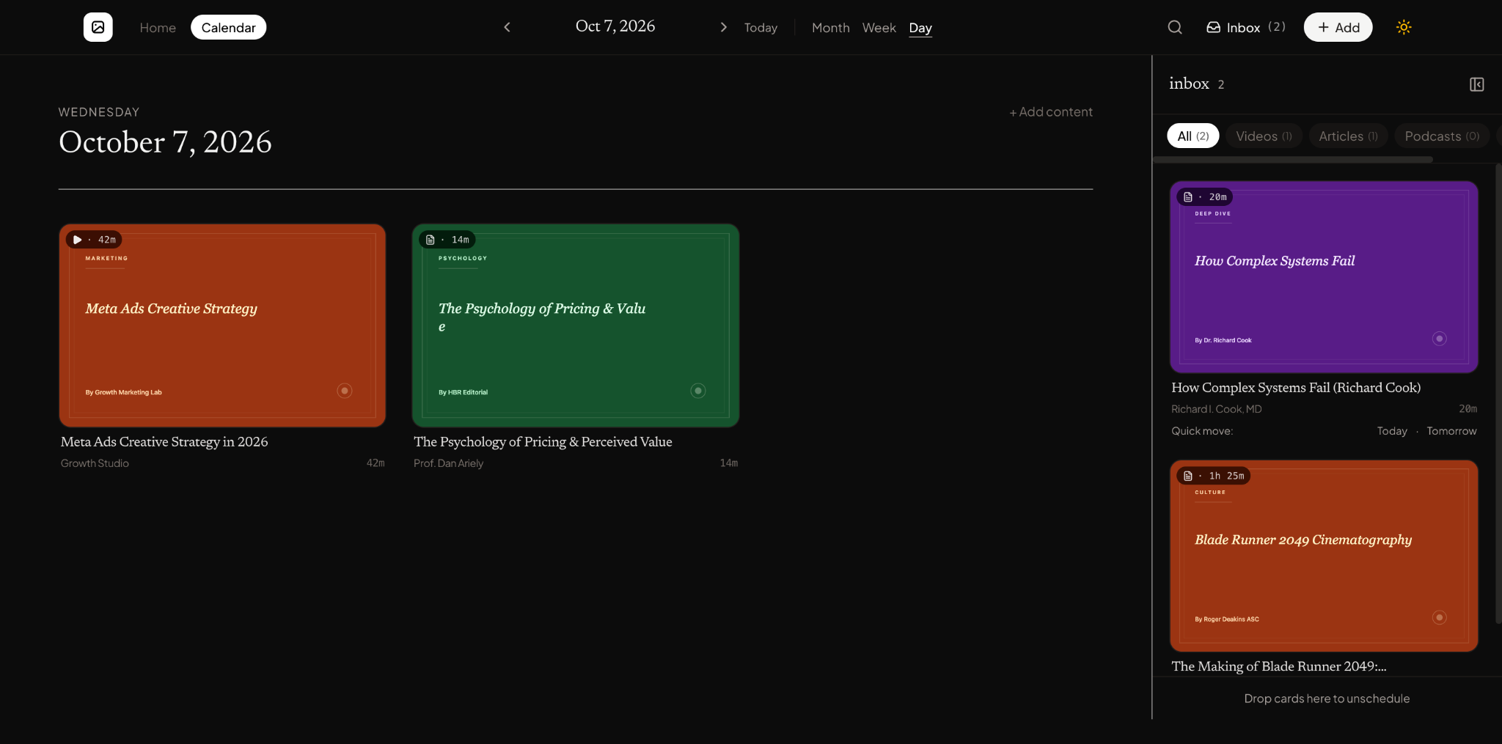

Screenshot 2
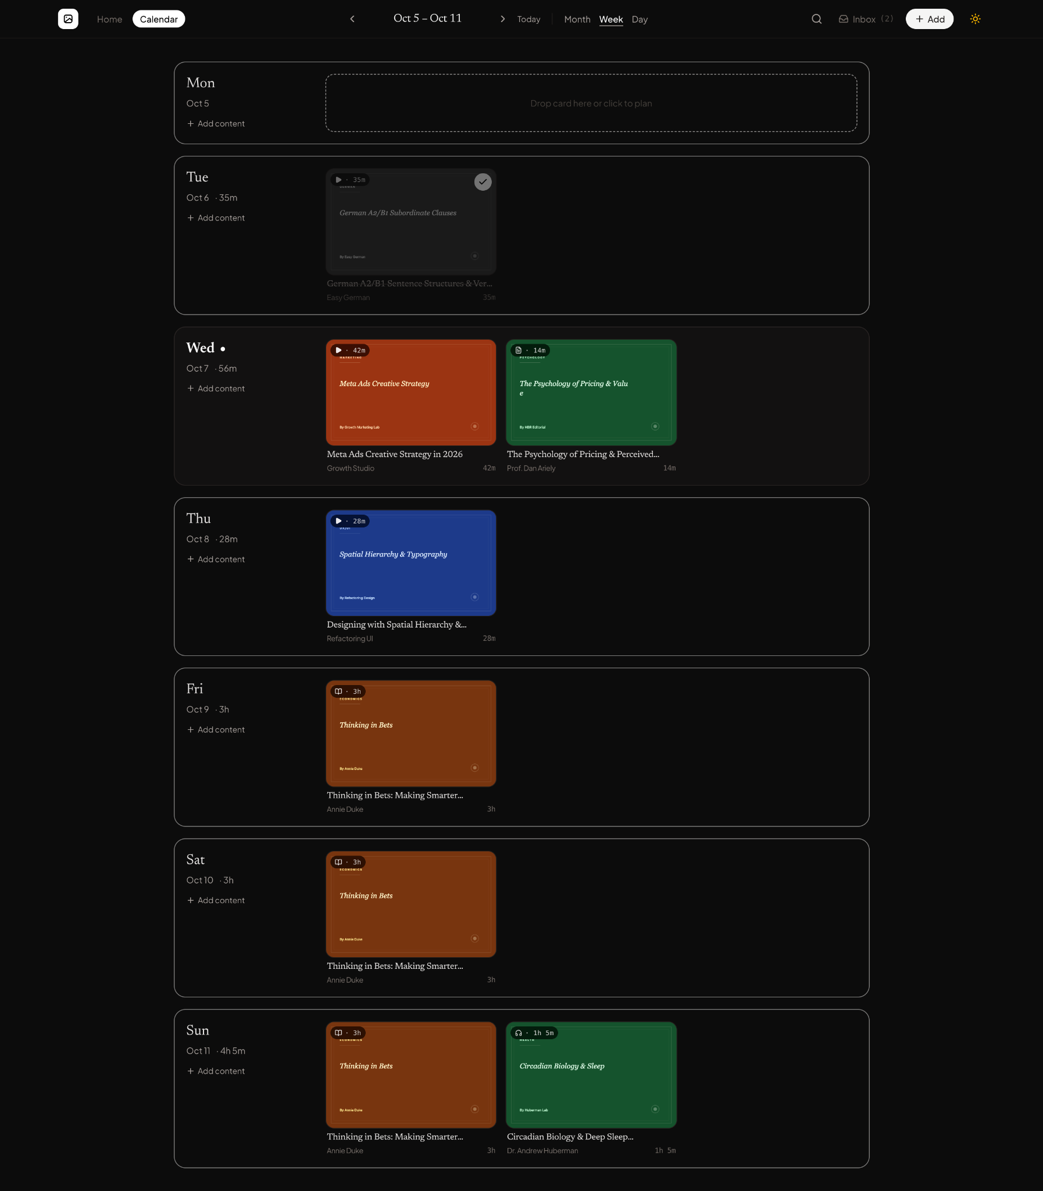

Screenshot 3
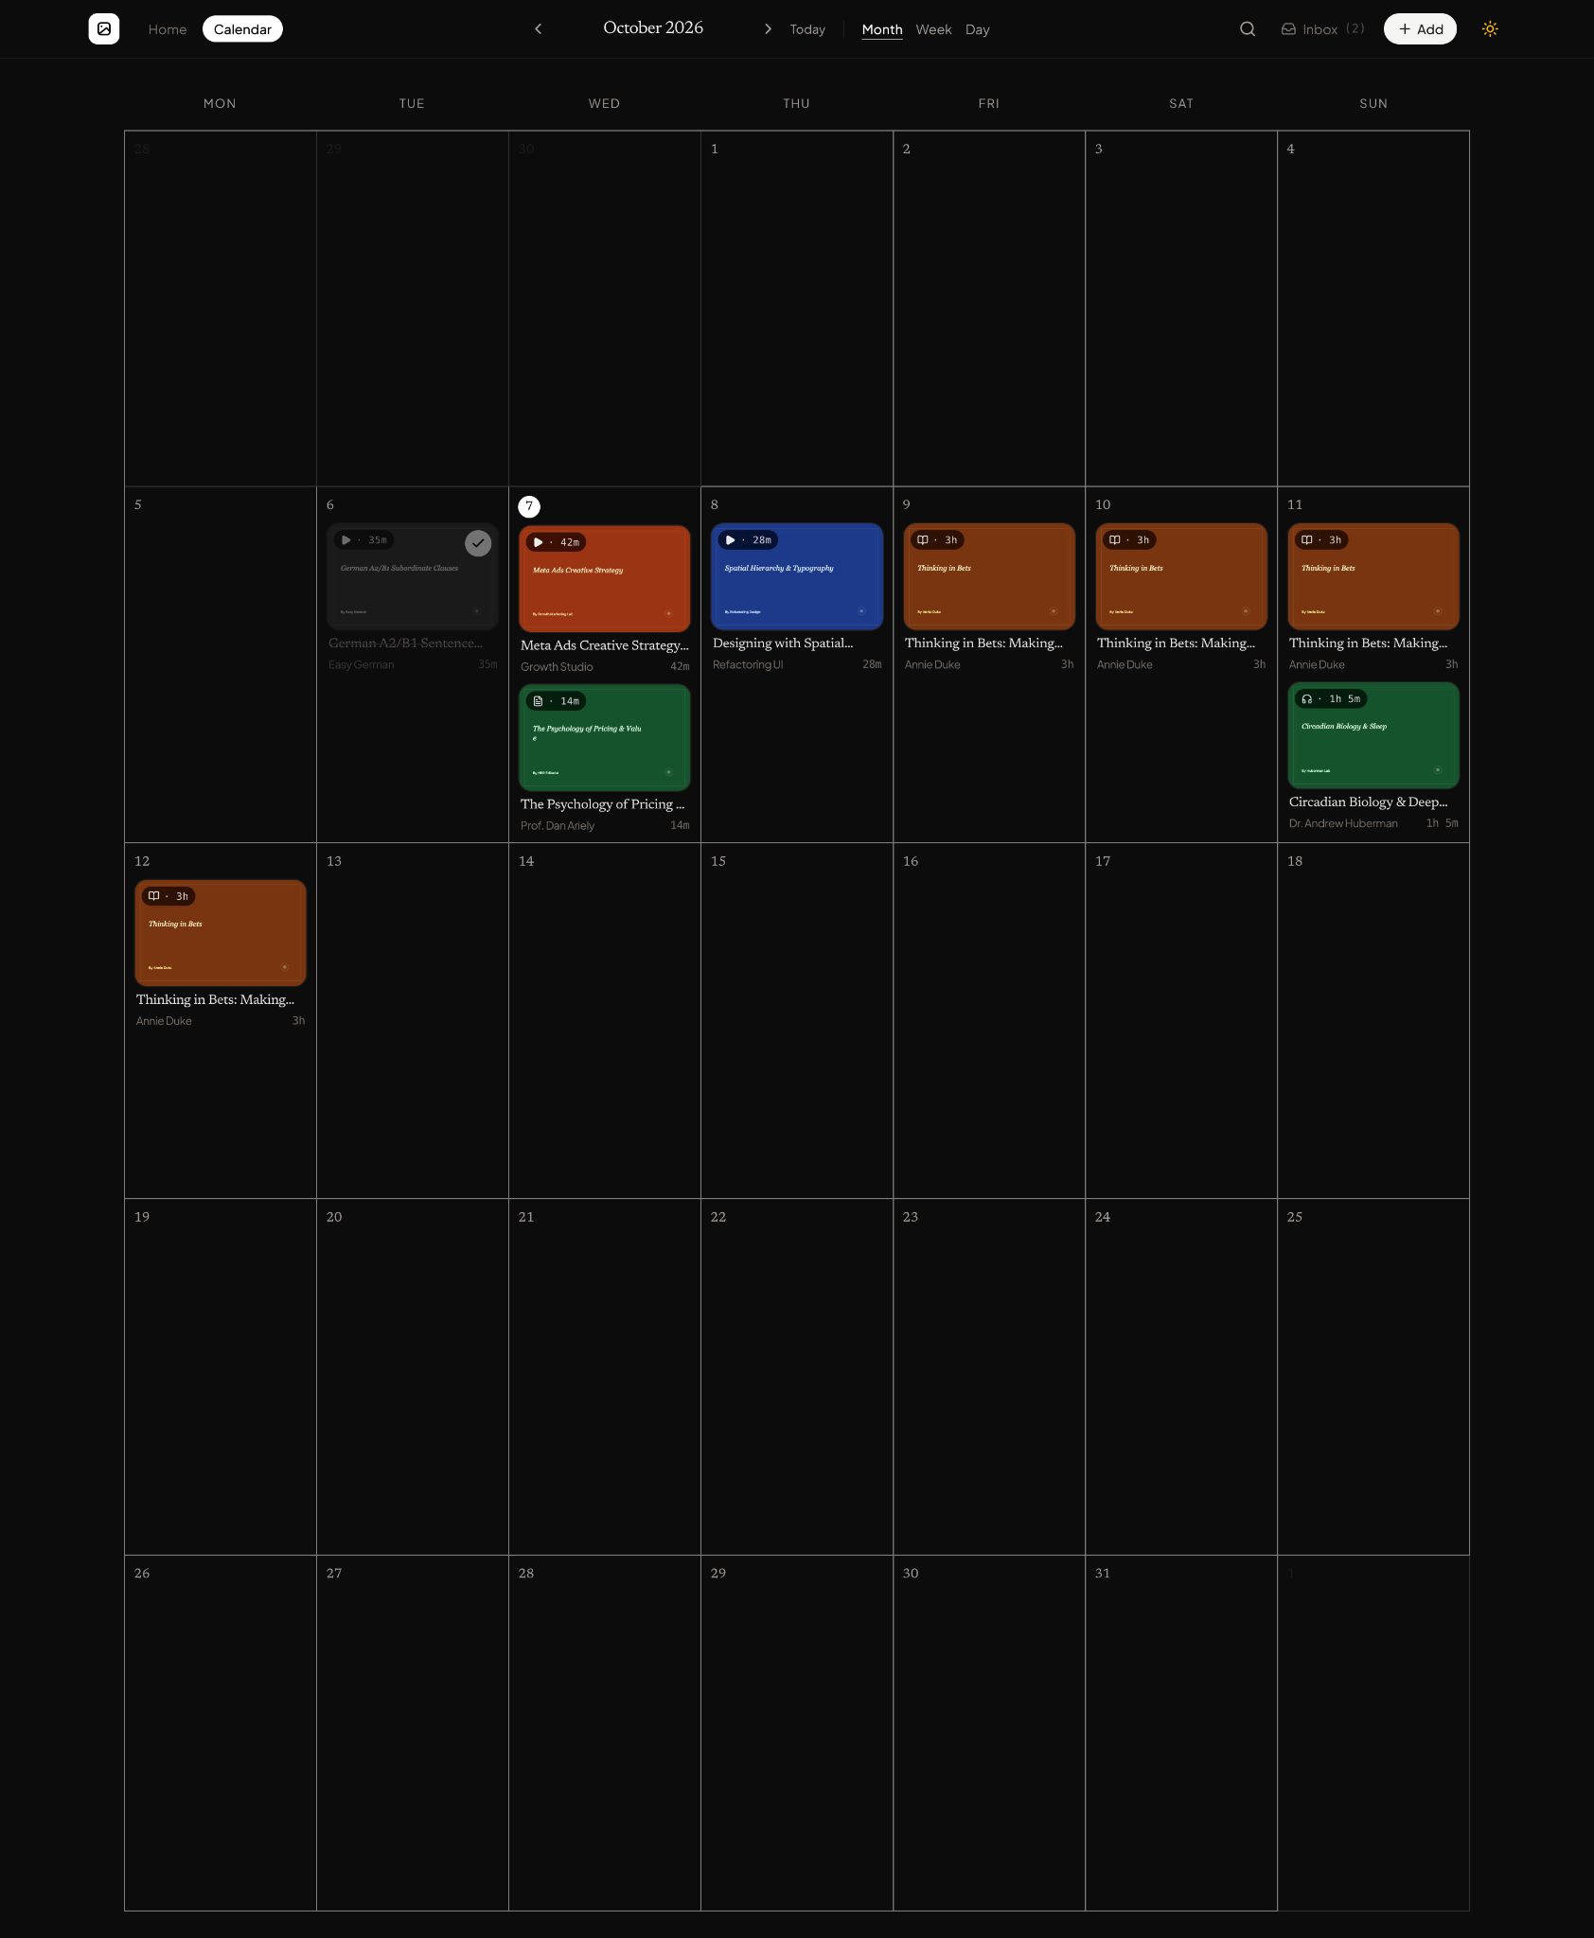

Screenshot 4
